|  |
| --- |
| **Exercise 5** |

**Copy this file and open it in Word or some other editor where you can insert images. Be sure to read "How to Copy the Results of a Query" found in Module 2 in Canvas.    This is how you will be answering the following questions.**

Using the Premier Products database:

1. Add sales rep Tina Webb, sales rep 85, to the REP table. All other columns except REP_NUM, LAST_NAME, and FIRST_NAME are null. When complete, type your construct here. Then, display the contents of the rep table. Insert your query and results here. Be sure all columns display.

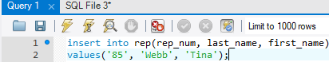

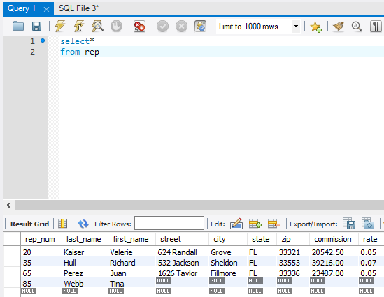

1. Change Tina Webb’s last name to Perry. When complete, type your construct here. Then, display the contents of the rep table. Insert your query and results here.

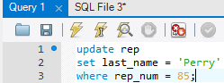

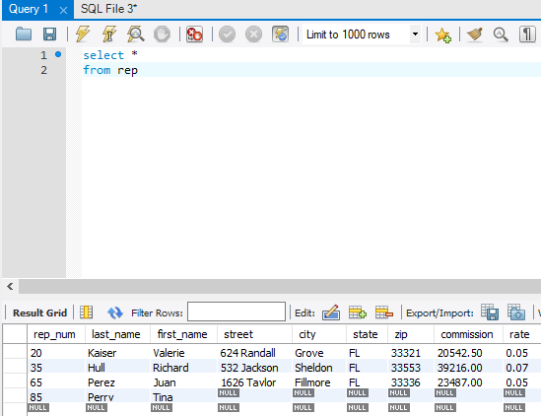

1. Delete sales rep 85. When complete, copy and paste your construct here. Then, display the contents of the rep table. Insert your query and results here.

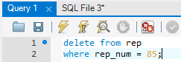

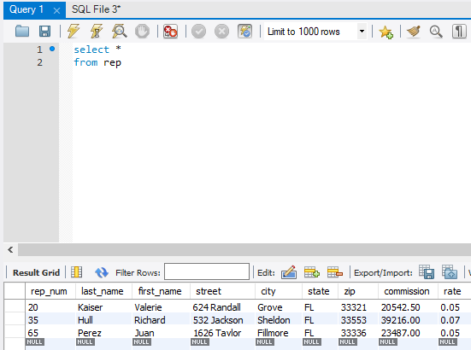

1. Change the name of customer 842 to All Season Sport. Copy and paste your construct here. Then, display the customer table. Insert your query and results here.

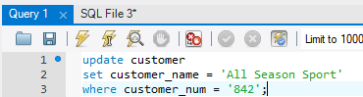

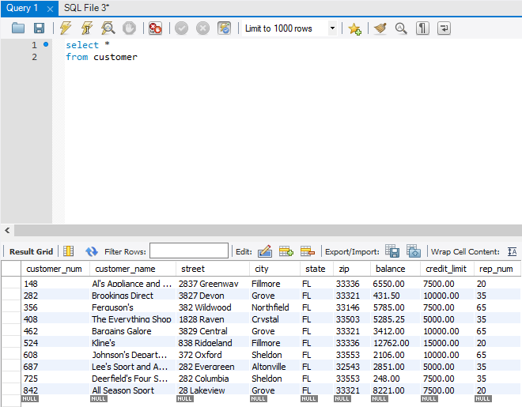

1. Change the description of part BV06 to “Fitness Gym”. Insert your query and results here.

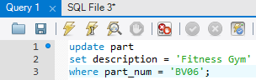

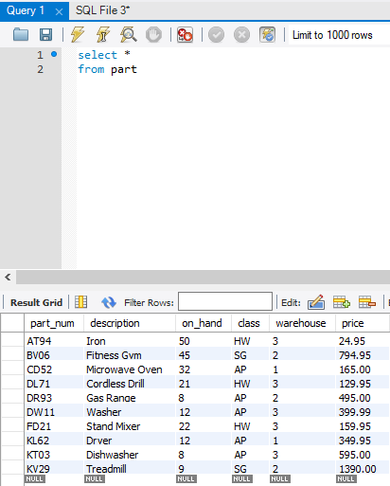

Using the Henry Books database:

1. Change the price of each book in the table with a current price of $14.00 to $14.50. Insert your query and results here:

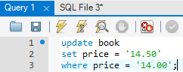

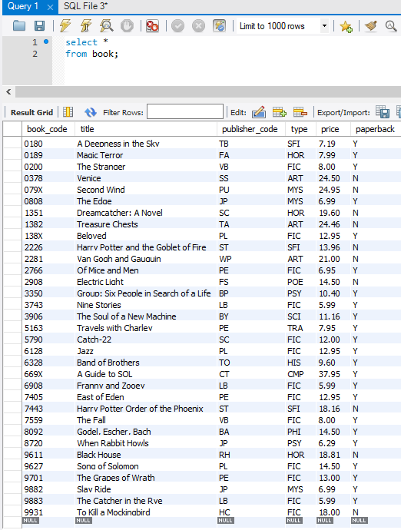

1. A new author has been added. The new author’s name is Elizabeth Drake. Insert your query and results here. Be sure the new author is displayed.

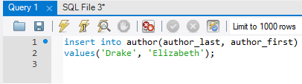

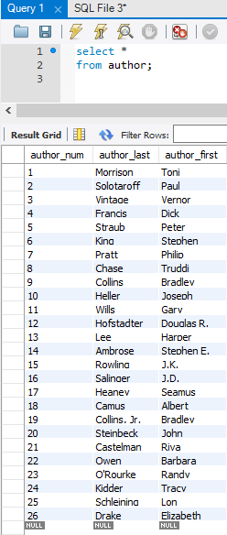

1. The book ordered from the new author will need to be added to the book table. Add “Introduction to Javascript” as book code 8306, it does come in paperback, published by PS (to be added in the next question), type is CMP, for a price of $98.95. Insert your query and results here. Be sure the new row displays.

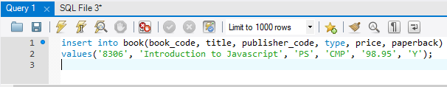

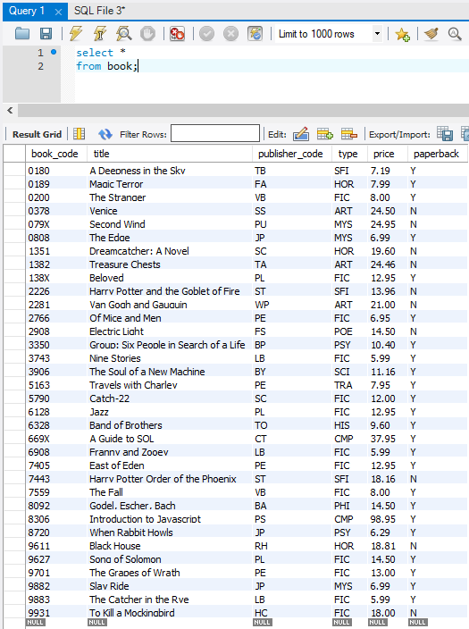

1. The new author uses a publisher not listed. A new publisher will need to be added. Add Pearson who is in London with a code of PS. Insert your query and results here. Be sure the new row displays.

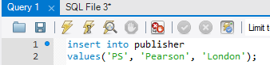

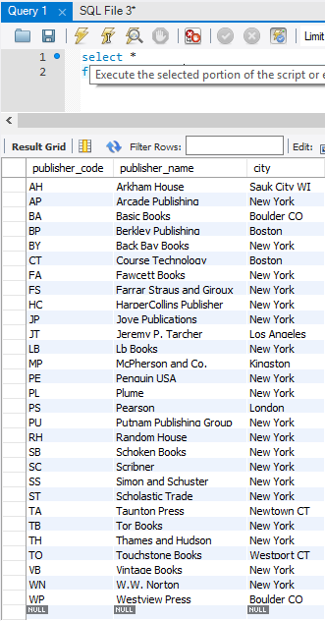

1. A mistake has been made. The Pearson’s office is in New York. Update the publisher table to reflect this change. Insert your query and results here. Be sure the changes are displayed.

